Third Sector Trends in England and Wales 2025
PRESS RELEASE
Embargoed Thursday 15th January 2026, 00.00 GMT
New report: Third Sector Trends in England and Wales 2025: income sources, assets and financial wellbeing.
Third Sector Trends has been surveying the voluntary, community and social enterprise sector every three years since 2010. In 2025, 8,680 responses were received across England and Wales. This is the only large-scale and fully representative longitudinal national survey in the UK which can produce robust and detailed comparative analysis at regional and national level.
The project is funded in 2025-26 by Community Foundation North East, Lloyds Bank Foundation England and Wales, Wales Council for Voluntary Action and Millfield House Foundation. This is the third of five national reports from Third Sector Trends in England and Wales 2025.

Grants are now even more popular as a principal source of income
Third Sector Trends explores how income sources are valued by third sector organisations (TSOs). Time-series analysis shows how perceptions of the value of income sources have changed in relative terms since 2010 (Figure 1 shows perceptions of each type of income high value ‘relative’ to others – each year adds up to 100%).
Perceptions of the value of grant funding have changed since 2010, reflecting a shift away from narratives about ‘grant dependency’ in policy circles. Income from subscriptions and investments have bounced back in recent years. The perceived value of earned income and contributions in kind have changed little in recent years; however, importance attached to income from the delivery of contracts has fallen heavily since 2022.
While there is a marketplace for loaning money to voluntary organisations for social investment purposes, few regard such income as an important element in their financial portfolio and, the signs are that this has decreased further in 2025.
Figure 1 Relative importance of income and in-kind support 2010-2025
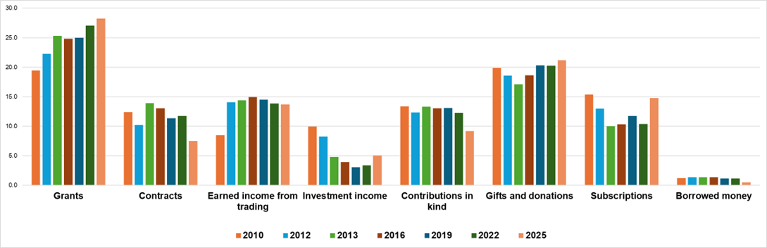

Trusts and foundations are shifting towards longer-term grants
Due to the Coronavirus pandemic which occurred in intervening years, relationships with grant funders have changed since 2019. Percentages refer to TSOs which ‘agree’ or ‘strongly’ agree with each statement (Figure 2).
- In 2019 only 46% of TSOs stated that they received unrestricted or ‘core funding’ which rose to 60% in 2022. Grant makers have eased back on unrestricted funding since then to 56% in 2025.
- In 2022, fewer TSOs reported that grant makers had taken the time to get to know them during the pandemic (48%) than in 2019 (57%). This has now bounced back to 57% in 2025.
- In 2019, grant makers’ demands that TSOs be ‘innovative’ in their work were at their height (74%), this fell dramatically to 50% during the pandemic but has since risen again to 62%.
- In 2019 and 2022, the percentage of organisations stating that grant makers made a long-term investment in their work remained about the same (31-32%). That has changed - 40% of TSOs now report that grant-makers are making a long-term investment in their work
- Support from grant makers to develop organisational skills dipped from 34% in 2019 to 27% of TSOs during the pandemic. Investment in skills has since bounced back to 35% in 2025.
As Rob Williamson, CEO of Community Foundation North East commented
“It’s encouraging that Third Sector Trends 2025 shows a positive direction of travel in grant-making practice from trusts and foundations. Whilst there has been some of the expected ‘bounce-back’ from the exceptional circumstances of the pandemic, it is clear an important shift is happening towards increased long-term, core funding, which is vital to enable charities and community groups to thrive. The drift back towards funders requiring ‘innovation’ gives some cause for concern – as a place-based funder supporting hundreds of grass-roots charities we know this can be a distraction for organisations who should be supported to keep doing what they do well - delivering support day-in-day-out for their communities.”

Figure 2 Voluntary organisations’ working relationship with grant-making trusts and foundations: 2019-2025 (Third Sector Trends in England and Wales, percentage 'agree' or 'strongly agree' 2019, n=3,958, 2022 n=5,978, 2025, n=8,556)
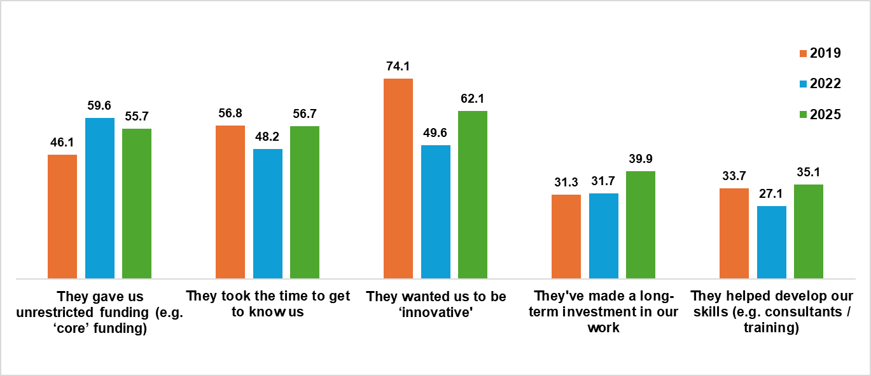

The third sector is turning its back on contracts to deliver public services
Political enthusiasm to involve voluntary organisations in the delivery of public services under contract remains strong and government has produced new guidelines to smooth procurement processes and set targets for the engagement of voluntary organisations (and small and medium-sized businesses) in this field.
Despite this and previous government efforts to incentivise and help prepare voluntary organisations to engage in the delivery of public services under contract, interest continues to decline steeply.
Amongst the biggest voluntary organisations, 64% remained involved between 2016 and 2019. That commitment collapsed during the Covid-19 pandemic to 54% and has fallen since to 50% in 2025. A decade ago, 23% of voluntary organisations were ‘ambivalent’ about getting involved in public service contracts due to lack of information, the need for support or perception of barriers to engagement; only 14% feel that way now – indicating a hardening of opposition to contract working.
In 2022, the main reason why voluntary organisations were withdrawing from this field of work is that contract values were too low to meet the cost of delivery (especially in a context of rising costs and difficulties in retaining and recruiting staff). These problems have been exacerbated in 2025 with hikes in the National Minimum Wage and employers’ National Insurance contributions.

The appeal and reliance upon earned income is weakening
Earning income from trading is an important element of finance for many TSOs. Income can be earned from contracts (as discussed above) or through self-generated trading of goods, charging for services or renting space.
- About 60% of organisations in the third sector earn a proportion of their income by delivering contracts or self-generated trading of goods or services.
- The proportion of TSOs which earned more than 80% of their income from trading fell to 14% during the pandemic but has since risen to 17% in 2025.
- The overall percentage of trading organisations has decreased from 68% in 2013 to 60% in 2025.
The appeal of and reliance upon trading is weakening. Only 55% of TSOs set up since 2020 are engaged in trading compared with 66% of those set up between 1945-1979. Only 9% of the newest organisations are highly reliant on trading (that is, earning more than 80% of their income); that percentage rises to 25% of those TSOs set up between 1900-1945.
As Professor Tony Chapman, Durham University, who leads the project said:
“Policy makers continue to express enthusiasm for ‘social enterprise’ to bolster local economies, especially in poorer areas. But that is a big ask – especially in areas where trading conditions are tough and the private sector has already withdrawn. This helps to explain why almost all trading organisations rely heavily upon a wide variety of additional income sources – especially grants and gifts together with in-kind support.”

Financial reserves have held up well since 2022
Third sector finances have held up well in 2025, though experiences vary depending upon the size and location of voluntary organisations.
- Most TSOs hold reserves (82%). This varies by size, 71% of micro TSOs have reserves compared with 97% of the biggest organisations.
- Around 45% of TSOs have not drawn on their reserves in the last year, irrespective of size, that percentage is unchanged from 2022 but much higher than in 2019 (37%).
- Only 16% of organisations have invested reserves in new activities (rising from 11% of the smallest TSOs to 35% of the biggest).
- Over a quarter of TSOs (27%) have used reserves for essential purposes such as rent or wages; rising from 21% of the smallest to 33% of the largest TSOs.
Half of voluntary organisations in the most affluent areas did not need to draw upon reserves compared with 38% in the least-affluent areas. In the poorest areas, 33% of TSOs have drawn upon reserves for essential costs compared with 23% of voluntary organisations based in the most affluent areas.
Prior to the pandemic, only 34-37 of TSOs were able to leave reserves untouched. During the pandemic, many more organisations had unused reserves (45%) due to a period of relatively free-flowing unrestricted grants and giving. That level of unused reserves has been sustained in 2025.
Between 2022 and 2025, the percentage of voluntary organisations using reserves for essential costs has fallen from 30% to 27%. It is useful to note that the percentage of TSOs using reserves for essential costs has remained remarkably similar since 2013 – suggesting that there is always a portion of the sector which is struggling to some extent financially (though not necessarily the same organisations).

Many in the third sector have a very positive outlook on future finances
Third Sector Trends’ triennial surveys ask respondents to make an assessment of their likely financial prospects over the next two years. Figure 7 shows the percentage of TSOs which expected income to rise over the next two years (green line) while the blue line shows the percentage of TSOs which achieved this ambition.
In the early years of the study, optimism was relatively low due to anxieties about the consequences of government austerity policies following the global economic crash of 2008 (only 19% of TSOs felt optimistic about rising income in 2010). Optimism steadily rose to 36% by 2019, but fell back to 32% as the effects of the pandemic receded in 2022 and have now fallen again to 28% in 2025.
While reality always falls well short of expectations, the percentage of TSOs with rising income has grown from a low point of 8% in 2010-11 to 18% in 2022 and 2025.

Figure 4 Tracking expectations and reality in TSOs’ income levels 2008-2028 (Third Sector Trends surveys, 2010 n=1,027, 2013 n=2,288, 2015 n=3,525, 2019 n=4,011, 2022 n=6,070, 2025 n=8,680)
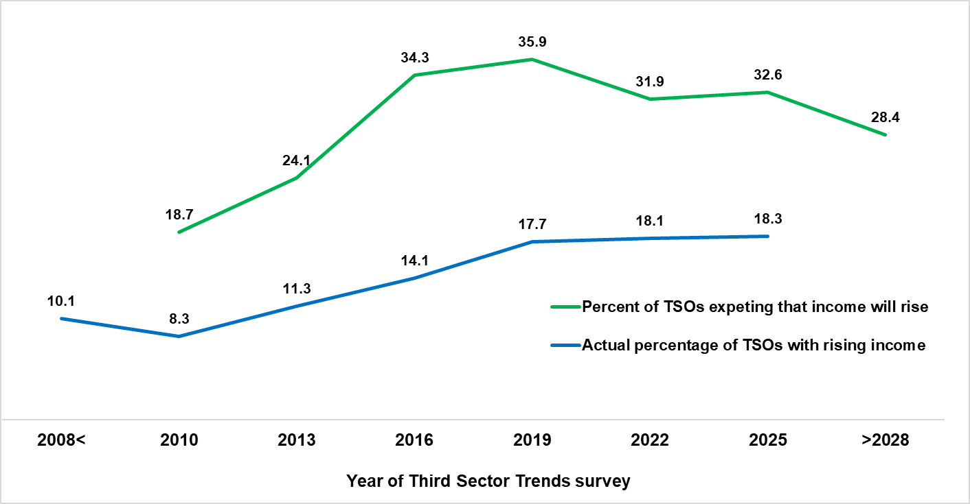

As report author, Professor Tony Chapman, Durham University concluded:
“External factors can shape the financial prospects of TSOs, such as national economic and labour market conditions, government action that substantially increase costs such as National Insurance Contributions and the National Minimum Wage, or significant shifts in the social objectives of trusts and foundations.
But to blame external forces alone for the plight of voluntary organisations’ financial prospects is a serious mistake. The laudable, but extremely high levels of ambition amongst charities to achieve their social objectives has the inevitable consequence of producing intense competition over finite financial resources. This means that there will always be winners and losers in financial terms.”

…ends

NOTE TO EDITORS
Third Sector Trends was established by Northern Rock Foundation in 2008 and is the largest and longest running empirical study of the sector in the UK. Community Foundation North East and St Chad’s College, Durham University are now responsible for the study’s legacy and continuation.
The analysis is underpinned by a dataset of 205,000 organisations drawn from the full range of registers of non-profit organisations so that survey evidence can be scaled-up reliably to produce credible and convincing findings on sector activities. It is designed to complement rather than replicate findings from the NCVO UK Civil Society Almanac, Charity Commission and 360 Giving.
This is the sixth iteration of the triennial survey which began in 2010. In 2025, its survey which closed on 30th September received a national and fully representative sample of over 8,680 responses from across England and Wales. The survey runs every three years. Analysis of the findings from the survey will be released over the next six months on separate topics including:
- Relationships, influencing and partnership working (October 2025)
- People in the voluntary sector and the social impact they produce (December 2025)
- Finance, assets and the wellbeing of voluntary organisations (January 2026)
- The contribution of the voluntary sector to place: a study of North East England in comparative context (February 2026)
- Sustaining organisational vitality and community impact (March 2026)
The project is funded in 2025-26 by Community Foundation North East, Lloyds Bank Foundation England and Wales, Wales Council for Voluntary Action and Millfield House Foundation.

For further detail on the study please contact:
Professor Tony Chapman, Policy&Practice, St Chad’s College, Durham University,
Tony.chapman@durham.ac.uk

Hannah Mackey-Christie, Senior Policy and Public Affairs Advisor, Community Foundation North East
hmc@communityfoundation.org.uk

